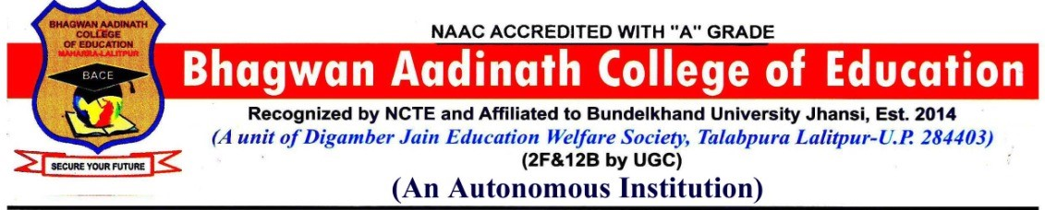

Governing Body of Bhagwan Aadinath College of Education (Autonomous)
Introduction:
The Governing Body is the apex administrative authority of Bhagwan Aadinath College of Education, functioning under the norms prescribed by the University Grants Commission (UGC) for autonomous colleges. It is responsible for overall policy formulation, strategic planning, and ensuring the effective governance of the institution.
The Governing Body works in alignment with the affiliating university, the UGC, and other regulatory bodies, while also safeguarding the college’s academic freedom and institutional autonomy.
Composition:
As per UGC Guidelines, the Governing Body consists of:

Number | Category | Nature
5 Members  one of them  to be Chairperson | Management | 1-Pradeep Kumar- Chair Person  2-Sanjeev Kumar  3-Khushboo Jain  4-Smt. Sakuntala Jain  5-Smt. Reeta Jain
2 Members | Teachers of the College | - Dr. Rohit Kumar  - Rakesh Kumar
1 Member | Administrative Staff of the College | Braj Mohan Verma
1 Member | Educationist or industrialist | Santosh Kumar Jain
1 Member | State Government nominee | Higher Education Officer Chitrakoot Jhansi Mandal Jhansi
1 Member | University Nominee | Prof. S.K. Katiyar
1 Member | Principal of College | Dr. Sunil Kumar Jain

Functions of the Governing Body: Subject to the existing provision in the bye-laws of the respective Autonomous College and rules laid down by the State Government/Parent University, the Governing Body shall:
1. Policy & Strategic Decisions: Formulates the long-term vision and mission of the college. Approves policies for academic, administrative, and financial operations.
2. Autonomy Governance: Oversees the proper implementation of autonomous status. Ensures compliance with UGC regulations and quality benchmarks.
3. Budget and Finance: Approves the annual budget, financial statements, and expenditure proposals. Monitors utilization of grants from UGC and other agencies. Institute scholarships, fellowships, studentships, medals, prizes, and certificates on the recommendations of the Academic Council
4. Academic Oversight: Approves new academic programs proposed by the Academic Council. Supports the development of curriculum, pedagogy, and assessment reforms. Approve new programmes of study leading to degrees and/or diplomas.
5. Appointments and Human Resources: Ratifies key appointments and promotions as per norms. Ensures adequate staffing and professional development. All recruitments of Teaching Faculty/Principal shall be made by the Governing Body/state government as applicable in accordance with the policies laid down by the UGC and State Government from time to time.
6. Infrastructure Development: Sanctions proposals related to physical and digital infrastructure upgrades.
7. Stakeholder Engagement: Promotes collaborations with industry, community, alumni, and other academic institutions.
8. Monitoring and Evaluation: Reviews the annual report, academic performance, and institutional outcomes. Takes corrective actions based on feedback from accreditation, audit, and stakeholders.
9. Legal and Statutory Compliance: Ensures adherence to rules and regulations of the affiliating university, UGC, NCTE, and Government bodies.
Term: The Governing Body shall be reconstituted every five years.
Meetings: Meetings of the Governing Body shall be held at least once every six months.
Quorum: Presence of a minimum 50% of Members will be the quorum.

