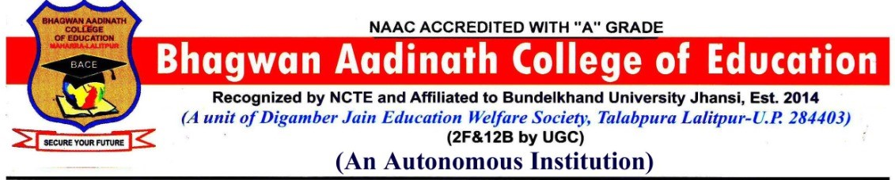

Academic Council of Bhagwan Aadinath College of Education
(Autonomous) Village –Maharra Lalitpur U.P.

The Academic Council is the principal academic authority of Bhagwan Aadinath College of Education, established as per the guidelines of the University Grants Commission (UGC) for autonomous institutions. It is entrusted with planning, monitoring, and regulating the academic affairs of the college.
The Academic Council plays a pivotal role in maintaining high academic standards, designing innovative curricula, ensuring quality teaching and assessment methods, and fostering academic freedom in line with the objectives of autonomy.
Functions of the Academic Council:
(a) To scrutinize and approve the proposals with or without modification of the Board of Studies with regard to courses of study, academic regulations, curricula, syllabi and modifications thereof, instructional and evaluation arrangements, methods, procedures relevant thereto, etc., provided that where the Academic Council differs on any proposal, it shall have the right to return the matter for reconsideration to the Board of Studies concerned or reject it, after giving reasons to do so.
(b) To make regulations regarding the admission of students to different programmes of study in the Autonomous College, keeping in view the policy of the Government.
(c) To make regulations for sports, extra-curricular activities, and proper maintenance and functioning of the playgrounds and hostels.
(d) To recommend to the Governing Body proposals for the institution of new programmes of study.
(e) To recommend to the Governing Body institution of scholarships, studentships, fellowships, prizes, and medals, and to frame regulations for the award of the same.
(f) To advise the Governing Body on suggestions(s) pertaining to academic affairs.
(g) To perform such other functions as may be assigned by the Governing Body.

Composition:
The Academic Council comprises:
Sr. No. | Faculty Name | Department
01. | Dr.Sunil Kumar Jain | Principal (Member Secretary)
Heads of Department
01 | Ramsevak Chandrakar, | Department of Arts
02 | Dr. Aruna Singh | Department of Science
03 | Neelesh Kumar Jain | Department of Commerce
04 | Dr. Rohit Kumar | Department of Education
05 | Ramakant Verma, | Department of Physical Education
06 | Dr. Nikhil Kumar Shrivastava, | Department of Business Management
07 | Mohit Arya, | Department of Computer Science
08 | Dr.Sharad Kumar Dubeydi, | Department of Hindi
09 | Dr. Preeti Jain, | Department of Sociology
10 | Dr.Arti Shrivastava, | Department of History

3.Four teachers of the Autonomous College representing different categories of teaching staff by rotation on the basis of seniority of service in the College
Sr. no. | Faculty Name | Department
01 | Rakesh Kumar | Education
02 | Dr. Vineeta Jain | Hindi
03 | Shiv Authar | Hindi
04 | Ankit Namdev | Sociology
4- Nominees of Outside of Autonomous College (experts/academicians from outside the Autonomous College representing such areas as Industry, Commerce, Law, Education, Medicine, Engineering, Sciences, etc)
Sr. No. | Faculty Name | Institution/University
01 | Santosh Kumar Jain | Industrialist Lalitpur
02 | Ad. Amit Kumar Jain | Advocate Lalitpur Civil Court
03 | Dr. Arvind Kumar Arya | Assistant Prof. Aadinath College of Education
04 | Deeksha Jain | Assistant Prof. Bhagwan Aadinath College of Pharmacy Lalitpur

5 Nominees of the University
Sr. No. | Faculty Name | Designation
01 | Prof. Sunil Kabia | Professor, Hotel Management Department ,B.U. Jhansi
02 | Prof.Archana Verma | Professor, Business Administration Department B.U. Jhansi
03 | Prof. R.K. Saini | Professor, Mathematics Science & Computer Application Department B.U. Jhansi.
6-
01 | The Controller of Examination | Dr. Sunil Kumar Jain

7-A faculty member nominated by the Principal (Member Secretary)–
Sr. No. | Faculty Name | Department
1 | Pooja Dixit | History
2 | Dr. Vineeta Jain | Hindi
3 | Ankit Namdev | Sociology
4 | Vipin Chand Bind | Hindi

Term: The term of the nominated members shall be three years.
Meetings: Meetings of the Academic Council shall be held at least once every six months.

